RestaurantRecommendation System

PreparedFor
Smart-Internz AppliedDataScienceGuidedproject

By
Sagar Sunil Bhosale D.Y.PatilAgricultureandTechnicalUniversity,Talsande

On
23June2025

Abstract
This project develops a personalized restaurant recommendation system based on user preferences, location, and dining history. It analyzes factors such as cuisine, price, and ratings to suggest suitable dining options.Machinelearningtechniqueslikecollaborativeandcontent-basedfilteringareusedfor accurate suggestions. The system enhances the dining experience by offering relevant and location- aware recommendations

FinalProjectReport

Contents
- Introduction
ProjectOverviews Objectives
- ProjectInitializationandPlanning Phase DefineProblem Statement ProjectProposal(Proposed Solution) InitialProjectPlanning
- DataCollectionandPreprocessing Phase DataCollectionPlanand RawDataSourcesIdentified DataQuality Report
Data Preprocessing
- ModelDevelopmentPhase
ModelSelectionReport InitialModelTrainingCode,ModelValidationandEvaluationReport
- ModelOptimizationandTuningPhase Tuning Documentation FinalModelSelectionJustification
- Results
Output Screenshots
- Advantages& Disadvantages
Advantages Disadvantages
- Conclusion
- FutureScope
- Appendix
SourceCode GitHub&ProjectVideoDemo Link

1Introduction
  - Project overviews
The Restaurant Recommendation System is a smart, data-driven solution designed to help usersefficientlydiscoverrestaurantsthatalignwiththeiruniquepreferencesandsituationalcontexts.As urbanization and mobile technologies continue to reshape consumer behavior, users are often overwhelmed by the sheer volume of available dining choices across platforms such as Google, Yelp, and Zomato. This leads to decision fatigue and sub optimal dining experiences. To solve this, the proposed system leverages a hybrid recommendation model combining collaborative filtering, content-based filtering, and geo location-aware services.The collaborative filtering component analyzeshistoricaluserbehavior,including past restaurant visits,ratings,and interaction patterns,to identify users with similar tastes and recommend restaurants favored by like-minded individuals.
Meanwhile,thecontent-basedfilteringmoduleevaluatesrestaurantattributes—suchascuisinetype, price range, ambiance, and dietary offerings—to match them with explicit user preferences.
To enhance practicality, geolocation data is integrated using GPS APIs or IP-based location tracking. Thisallowsthesystemtodynamicallyadaptitsrecommendationsbasedontheuser'scurrentpositionor aspecifiedlocation,ensuringthatresultsareboth relevantandaccessible. Forexample,auserseeking budget- friendly vegan food in a new city would receive highly localized and personalized recommendations.
Furthermore, the system is designed with adaptive learning capabilities. Using techniques like reinforcementlearningorpreferencefeedbackloops,therecommendationengineimprovesovertimeby understanding user behavior patterns, modifying weightage of features, and incorporating real-time feedback such as likes, bookmarks, or direct reviews.
  - Objectives

    - To design and implement a recommendation engine that effectively filters and ranks restaurantsbasedonindividualuserpreferences,includingfoodtype,cost,ambiance,anddietary needs.
    - Toapplymachinelearningmodels,suchascollaborativefiltering(user-basedanditem-based) and content-based filtering, to identify patterns in user behavior and restaurant attributes.
    - Toincorporatelocation-awarefeaturesusingGPSoruser-inputtedlocationdata,ensuringthat recommended restaurants are conveniently accessible to the user.
    - Togatherandanalyzerestaurantreviewsandratings frompublicsources(e.g.,Yelp,Google Reviews, or internal datasets) to improve the trustworthiness and relevance of suggestions.
    - Tocreateauser-friendlyinterfacethatallowsuserstoinputpreferences,viewrecommended restaurants, and interact with the system seamlessly.
    - Todevelopafeedbackmechanism thatcollectsusersatisfactiondatapost-visittorefinefuture recommendations and enhance personalization over time.
    - Toensurescalabilityandadaptabilityofthesystemforuseindifferentgeographicregionsor for integration into existing food delivery or travel applications.

2ProjectInitializationandPlanningPhase

DefineProblemStatement
2ProjectInitializationandPlanningPhase
ProblemStatements(RestaurantRecommendationsystem):

PS  No. | I am (Customer) | I’mtryingto | But | Because | Whichmakesme feel
PS-1 | Atouristina new city | Findgoodlocal restaurants | Idon’tknowthe area well | I lack local  knowledge or reviews | Confused and unsureofwhereto eat
PS-2 | Avegetarian diner | Get recommendations for veg-only restaurants | Most apps showmixed cuisineplaces | I want strict dietaryoptions | Frustratedand unsupported
PS-3 | Arestaurant owner | Attractmore customers through recommendation platforms | Myrestaurantis not being recommended often | The system doesn’t promote new or small businesses | Invisibleand discouraged
PS-4 | A student on a tight budget | Findaffordable but tasty restaurants | Expensive optionsare shownfirst | Filters don’t prioritizepriceor value | Overwhelmedand discouraged
PS-5 | Adeliveryapp user | Getsuggestions based on past orders | It doesn't adapt to my taste | Thesystemlacks learning | Frustratedby repetition
PS-6 | Aparentof youngkids | Findkid-friendly and hygienic restaurants | No way to filter forchild-friendly | Lackofsafetyand family-focused featuresamenities | Anxiousabout experience

PS- 7 | A small restaurant owner | Increase customer footfallvia platforms |  | Mybusinessis buriedunder chainlistings | Ranking algorithms  favorlarge brands | Discouragedand invisibleguide
PS-8 | Anew-in-town resident | Explore culturally diversefood options | Unaware of hiddengemsin my area |  | No cultural/ethnic tagsoruserreviews | Disconnectedand bored of same cuisine
PS-9 | Afooddelivery platformanalyst | Monitorfood safety and restaurant quality | Can’tverify ingredientsafety from menus |  | Platforms lack A food item scanner or trackers | IConcernedabout sconsumer trust
PS-10 | Adatascientist | Analyzefood trends from reviews | Datasets are messy,biased,or unavailable |  | Lack of structure sentimen an metadata | Blockedinmodel building and research
PS-11 | A  foodie traveler | Findtop-rated local restaurants in new cities | Recommendations don’tmatchmy tasteor location |  | Generic,irrelevant suggestions | Frustrated and unsurewhereto eat
PS-12 | Arestaurant owner | Improvemy visibilityon food apps | My reviews are outdatedorlow- rated |  | I can’t easily respondorupdate info | Powerlessand misrepresented
PS-13 | A health- conscious customer | Find healthy eating options nearby | Menusandcalorie info are missing |  | I can’t make informeddecisions | Disconnected frommyhealth goals
PS-14 | A  healthconscious individual | Track the health benefits of different mushrooms | I can’t  identifywhat’sin the store or dish |  | There’snoeasyapp forinstant scanning | Disappointed and  disconnected frommyhealth goals




ProjectProposal(ProposedSolution)
ProjectProposal(Proposed Solution)
This project proposal outlines a solution to address a specific problem. With a clear objective, defined scope, and a concise problem statement, the proposed solution details the approach,keyfeatures,andresourcerequirements,includinghardware,software,andpersonnel

ProjectOverview
Objective | Todevelopasystemthatprovidespersonalizedandefficientrestaurant recommendationsby analyzing user preferences,dietary requirements, location, and budget.
Scope | The project aims to serve users seeking restaurant suggestions that match their individual lifestyle choices and dining preferences. It will operate acrossvariousregions,consideringreal-timedataandqualitativereviews.
ProblemStatement
Description | Finding restaurants tailored to specific needs is often time-consuming and inefficient.Usersfrequentlyrevisitthesameplaces,missingdiverseoptions that better match their preferences.
Impact | Solvingthisproblemimprovesusersatisfaction,encouragesexplorationof new dining options, and reduces time spent on decision-making.
ProposedSolution
Approach | Thesolutionemploysinnovativerecommendationalgorithmsthatfactorin both user input and external data like ambiance, ratings, and reviews. It adapts dynamically to user feedback and real-time changes.
Key Features | - Personalizedrecommendations  - Real-timedataanalysis  - Integrationofuserreviews  - Considerationofdietaryandbudget constraints  - Scalableinfrastructure

ResourceRequirements

ResourceType | Description | Specification/Allocation
Hardware
ComputingResources | 8-coreCPUsandoptional GPU | 2xNVIDIAV100GPUs
Memory | RAM | Minimum8GBRAM
Storage | SSD | 1TBSSDforstoringuserdata and restaurant metadata
Software
Frameworks | Python frameworks | Python, Flask
Libraries | Additionallibraries | Pandas, NumPy, Scikit-learn, TensorFlow,BeautifulSoup(for scraping), and NLTK (for review analysis)
DevelopmentEnvironment | IDE,versioncontrol | Jupyter Notebook
Data
Data | Size:-Approx.50,000–100,000  recordsinitially;scalablebased on user growth,  Format:-CSVfortabular datasets, Text/HTML for scraped reviews | Aggregatedfromcrowdsourced restaurantplatforms(e.g.,Yelp, Zomato APIs), user feedback, and public review datasets

InitialProjectPlanning
ProductBacklog,SprintSchedule,andEstimation

Spri nt | Functional  Requirement (Epic) | User  Story Number | UserStory/ Task | Story Points | Priority | Sprint StartDate | Sprint  EndDate (Planned)
Spri nt-1 | User Preferences Input | USN-1 | As a user, I can enter my  foodor Hotel preferences. | 2 | High | 01 June  2025 | 02 June  2025
Spri nt-1 | Recommendation Engine | USN-2 | As a user, I can get restaurant recommendati ons based on my  preferences. | 3 | High | 02 June  2025 | 02 June  2025
Spri nt-2 | Review &Rating Integration | USN-3 | As a user, I can view restaurant reviews and ratings  fetchedfrom the dataset. | 2 | Medium | 03 June  2025 | 04 June  2025
Spri nt-2 | UI/UX  Enhancement | USN-4 | As a user, I can view results in a user-friendly interfacewith filters and sorting. | 2 | Medium | 04 June  2025 | 05 June  2025




2 DataCollectionandPreprocessingPhase

DataCollectionPlanandRawDataSourcesIdentified
DataCollection Plan

Section | Description
Project Overview | Developarestaurantrecommendationsystemtoassistusersinfinding dining options based on their preferences, location, and other relevant factors.Byanalyzinguserpreferences,restaurantratings,andlocation data, this project aims to provide personalized recommendations that enhance the dining experience for users.
DataCollection Plan | The dataset used for this project was sourced from Kaggle and contains detailed information on over 9,000 restaurants in Bangalore, including attributeslikename,location,cuisine,ratings,andpricing.Thispublicly available dataset was collected to support analysis and predictive modeling related to restaurant ratings and customer preferences.
RawDataSources Identified | Therawdataforthisproject wasobtainedfromtheKaggledataset titled “ZomatoBangaloreRestaurants”byHimanshuPoddar.Thedatasetis publicly available at  https://www.kaggle.com/datasets/himanshupoddar/zomato-bangalore- restaurantsandincludeskeyrestaurant-relatedattributessuchasrestaurant names, locations, cuisines, average costs, online delivery availability, and user ratings.

RawDataSources

Source Name | Description | Location/URL | Format | Size | Access Permissions
SmartInterz Provided Dataset | Restaurant-leveldata including name, location, cuisines, rating and cost. | Data-Set zomato- bangalore- restaurants | CSV | ~ 93MB | Public



DataQualityReport

DataSource | DataQualityIssue | Severity | ResolutionPlan
Dataset (Restaurant reviewsand metadata) | Missingvaluesinfields like restaurant name, location, or ratings | Moderate | Performdataimputationusingtechniques like mean/mode for numeric values and most frequent value for categorical data.  Alternatively, remove rows with critical missing fields.
Dataset(User reviews) | Duplicateuserreview entries | Low | Remove duplicate records using drop_duplicates() in pandas or SQL DISTINCTqueries.Usedatetimeparsing libraries (e.g., pandas.to_datet ime) to standardize all date/time fields.
Dataset (Restaurant metadata  ) | Inconsistent formats (e.g.,locationwrittenin different ways like "NY", "New York") | Moderate | Apply data standardization techniques, usingstringfunctionsorregexpatternsto unify the format.
Dataset(User preferenc es) | Sparse data or insufficientuserhistory | High | Implement fallback strategies such as popularity-based or content-based recommendationswhenuserdataislacking.



  - DataPreprocessing
DataPreprocessing
The images will be preprocessed by resizing, normalizing, augmenting, denoising, adjusting contrast,detectingedges,convertingcolorspace,cropping,batchnormalizing,andwhitening data. These steps will enhance data quality, promote model generalization, and improve convergenceduringneuralnetworktraining,ensuringrobustandefficientperformanceacross various computer vision tasks.

Section | Description
Data Overview | The dataset contains restaurant information from Zomato, includingname,reviews,ratings,cuisines,cost,andmore.The data is cleaned, deduplicated, and preprocessed for building a content-based recommendation system.
Resizing | Notapplicablefortext data.
Normalization | Ratingsarenormalizedtoa1-5scaleusingMinMaxScaler. Text is lowercased and punctuation is removed.
Data Augmentation | Notapplicablefortextdata.
Denoising | Textiscleanedbyremovingnewlinecharactersand punctuation.
Edge Detection | Notapplicablefortextdata.
ColorSpace Conversion | Notapplicablefortextdata.
ImageCropping | Notapplicablefortextdata.
BatchNormalization | Notapplicablefortextdata.
DataPreprocessingCode Screenshots

LoadingData | 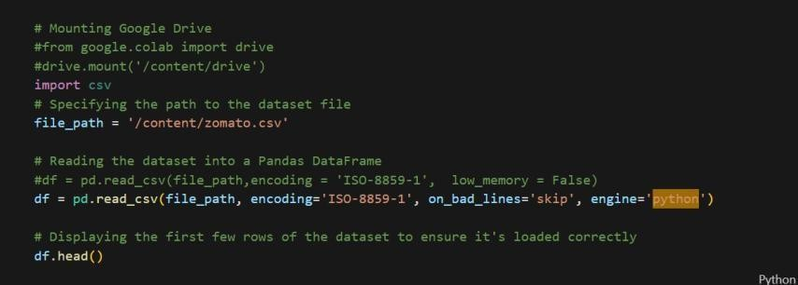
Resizing | Not applicable
Normalization | 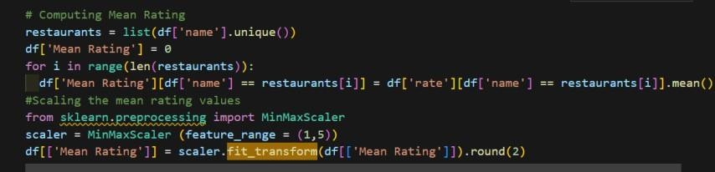
Data Augmentation | Not applicable
Denoising | 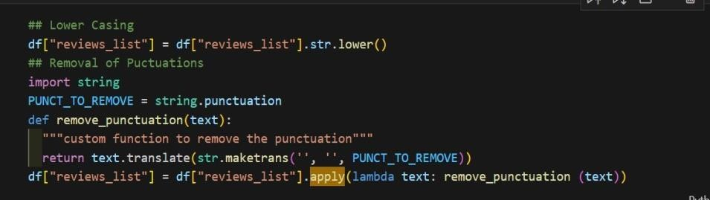
Edge Detection | Not applicable
ColorSpace Conversion | Not applicable
ImageCropping | Not applicable
BatchNormalization | Not applicable






ModelDevelopmentPhase

ModelSelectionReport
Model | Description
Content-Based Filtering | Content-basedfilteringrecommendsrestaurantsbycomparinguserpreferences (e.g.,cuisinetype,pricerange,dietaryrestrictions)withrestaurantattributes.It focuses on similarities between items and the user's profile without relying on other users’  data. Thismethod iseffective for users with unique tastes butmay strugglewithlimiteduserprofiles(coldstart).
Collaborative Filtering | Collaborative filtering leverages the preferences of similar users to make recommendations. Ituses historical ratingsandreviews toidentify patterns. This  modeliseffectiveindiscoveringnewitemsbutcansufferfromsparsityandcold startproblemsifdataislimited.
Hybrid Recommendatio n Model | This combines content-based and collaborative filtering to overcome the limitationsofeachmethod.Byintegratingbothuserpreferencedataandbehavior ofsimilarusers,hybridmodelsimproverecommendationaccuracy,diversity,and  scalability. It is particularly useful in scenarios with large, sparse datasets like restaurantrecommendations.
Matrix Factorization | Matrix factorization techniques decompose the user-item interaction matrix into latentfeatures,capturingunderlyingpatternsin user preferences. SingularValue  Decomposition(SVD)isacommonapproach.Itiscomputationallyefficientand workswellforlargedatasetsbutrequiresenoughratings.
DeepLearning (Neural Networks) | Neural networks can be used to build recommendation systems by learning complex,non-linearrelationshipsbetweenusersandrestaurantsfromrichfeature sets including reviews, preferences, and metadata. While powerful, they require large datasets and are computationally intensive.

Conclusion:

ModelSelected
Hybrid Recommenda tion Model | The hybrid model was selected because it addresses the limitations of both content- basedandcollaborativefilteringapproaches.Iteffectivelyhandlesthecoldstartand sparsity issues by integrating multiple data sources such as user profiles, restaurant attributes, and behavioral data. This results in more personalized, diverse, and accurate recommendations, making it highly suitable for a restaurant  recommendationsystemwithvaryinguserpreferencesanddataavailability.

InitialModelTrainingCode,ModelValidationandEvaluation Report
InitialModelTrainingCode,ModelValidationandEvaluationReport Initial Model Training Code (5 marks):
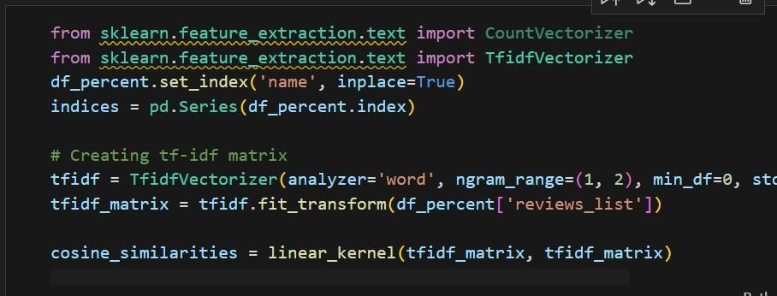
ModelValidationandEvaluationReport(5marks):

Model | Summary | TrainingandValidationPerformance Metrics
Model1 | Content-basedRecommendation | TrainingMetrics-None(unsupervised,no explicit training phase)  Validation Metrics - None (recommendationsareinspectedmanually)

3ModelOptimizationandTuning Phase

3.1TunningDocumentation
HyperparameterTuning

Model | TunedHyperparameters
Model 1: Content-Based Filtering | - SimilarityMetric:Cosinesimilaritywasusedastheprimarymetricto compute similarity between restaurants based on features like cuisines, rating, and cost.  - TopNRecommendations:Thenumberoftopsimilarrestaurants returned was tested with values like 5, 10, and 15.  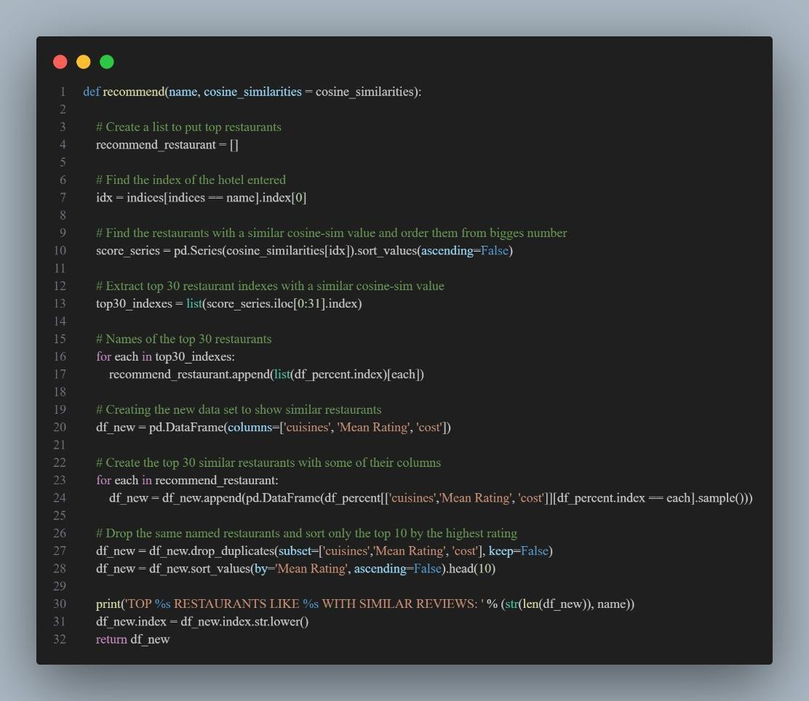




Model 2: Collaborative Filtering | - Algorithm:SVD(SingularValueDecomposition)fromtheSurprise library.  - LearningRate:Tuned valuessuchas0.005,0.01,and0.02weretested.  - Regularization:Parameterssuchas0.02,0.05weretriedtoavoid overfitting.  - NumberofEpochs: Adjustedbetween20 and100 epochs.

FinalModelSelectionJustification

FinalModelSelection Justification:

Final Model | Reasoning
Model1:Content- Based Filtering | Selectedduetoitssimplicityandgoodperformancewithoutrequiring detailed user history. It gave interpretable and relevant results using restaurant features like cuisines, ratings, and cost.



4Results

OutputScreenshots

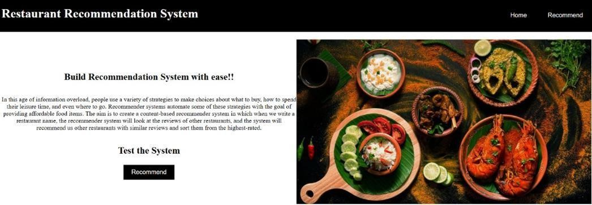
Home Page:

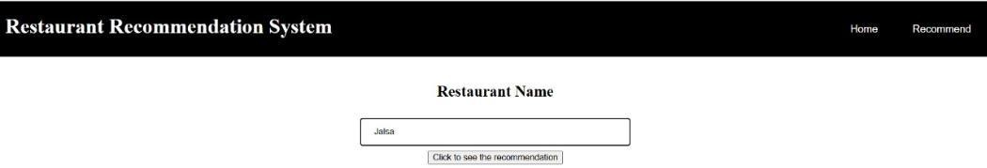
InputPage:

Example:-



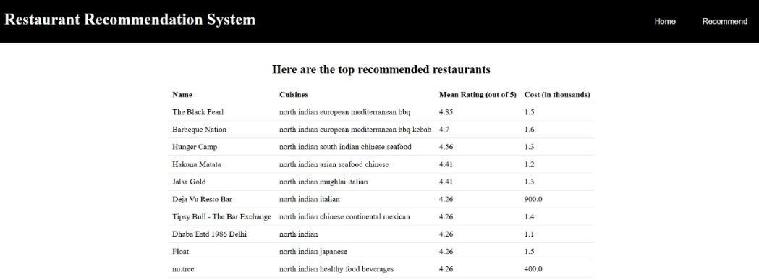

5Advantages& Disadvantages
Advantages:
- PersonalizedUserExperience:Tailorsdiningoptionsbasedonuserpreferences,dietaryneeds, and previous behaviour.
- Time-saving:Reducestheeffortneededtosearchandchoosea restaurant.
- ImprovedDiscoverability:Helpssmallerornewrestaurantsgainvisibilitythrough recommendations.
- Data-DrivenDecisions:Usesuserratings,reviews,andlocationdatatomakeinformed suggestions.
- EnhancedCustomerSatisfaction:Usersaremorelikelytoenjoytheirmealswhen recommendations align with their preferences

Disadvantages:
- PrivacyConcerns:Collectingandanalyzinguserdata(location,preferences)canraiseprivacy issues.
- BiasinRecommendations:Algorithmsmightfavorsponsoredlistingsorhigh-traffic restaurants, reducing diversity.
- DependenceonUserData:Inaccurateorlimiteddatacanleadtopoorrecommendations.
- Over-Personalization:Usersmightbeconfinedtosimilarchoices,missingoutonnewor diverse dining experiences.
- ScalabilityIssues:Maintainingsystemaccuracyandperformancecanbecomechallengingas the user base grows.

6Conclusion
A restaurant recommendation system is a powerful tool for enhancing the dining experience by delivering tailored suggestions based on user behavior, preferences, and location. While it offers significant benefits such as convenience, personalization, and efficient decision-making, it also presentschallengesincludingdataprivacy,systembias,andtheriskofuserdatadependency.Future advancements in AI, real-time analytics, and user interface technologies promise to make such systems more intelligent, inclusive, and immersive. With careful implementation and ethical considerations, this system can transform how users explore and enjoy culinary option

7FutureScope
  - IntegrationwithAR/VR:Inthefuture,userscouldtakevirtualtoursofrestaurantsorview their ambiance in AR before booking.
  - VoiceAssistantCompatibility:IntegrationwithSiri,Alexa,orGoogleAssistanttoprovide hands-free restaurant suggestions.
  - EnhancedPersonalization:Usedeeplearningandbehavioralanalyticstorefine suggestions based on dietary restrictions, allergies, and eating habits.
  - Real-timeDataUtilization:Incorporatingreal-timefactorslikewaittimes,specialoffers, and crowd density for more dynamic recommendations.
  - MultilingualSupport:Expandingthesystemtosupportvariouslanguagestocatertoa global audience.
  - SocialMediaIntegration:Useofsocialmediatrendsandcheck-instoimprove recommendation relevance.
  - SustainabilityPreferences:Factoringineco-consciousdiningchoices(e.g.,locally sourced, plant-based, or low-waste restaurants).

Appendix
  - Source Code
[ Restaurant-Recommendation-System ]

  - ProjectVideoDemoLink :
VideoDemoLink: [ Demo Link ]

